**Lesson06 Explore Docker Container in Azure App Service**

**Notes: -**

**1-at first we create azure container registry**

**2-we download and install docker desktop in order to publish .net core project as image on azure container registry**

**3-on .NET core project > publish > Azure Container Registry > we select the azure container registry we created before**

**4-in Azure Portal > Web App**

**(we check azure subscription and resource group)**

**(we select docker container with select O.S and select app service)**

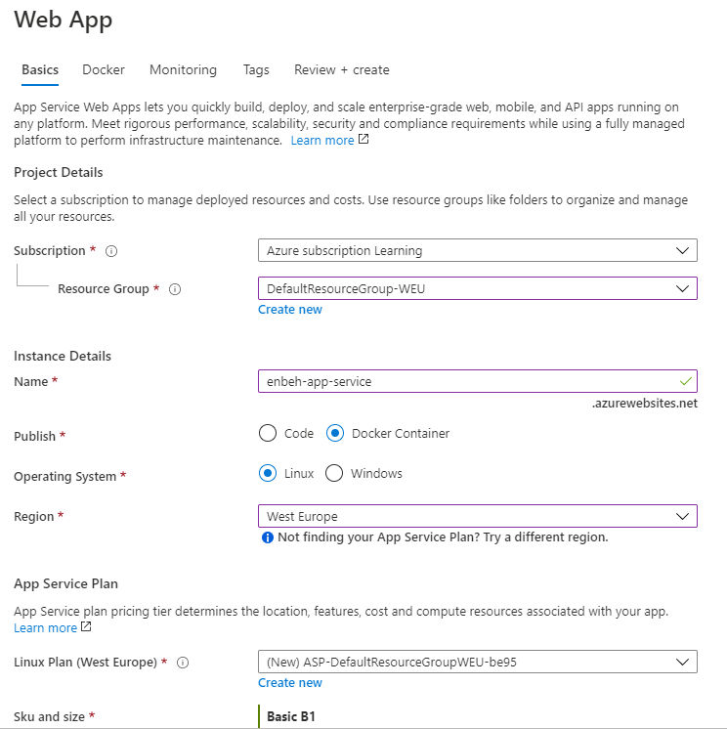

**5-we have the azure container registry and the custom docker image**

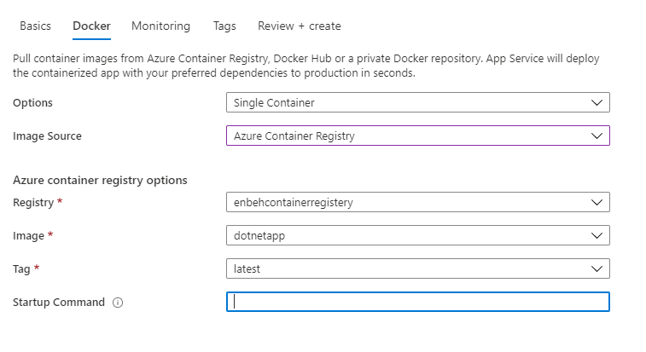

**6-we see it will create 2 resource azure service plan + app service**

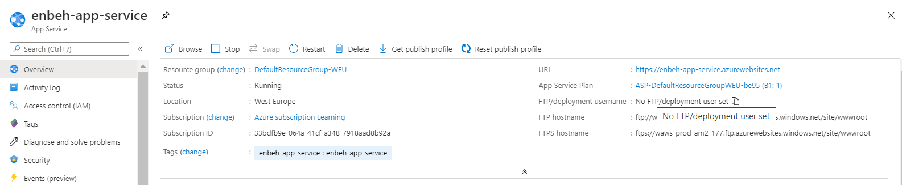

**Copy and paste URL and the custom docker image will be applied**